Project #4 Verification

Speed Gauge  
Cooper Brotherton  
Instructor: Dr. Michael Jo  
ECE230-03

# Requirements

* Servo control signal
  + The period shall be 25 milliseconds (±100μs)
  + Pulse-width for minimum position (-90°) shall be 0.75 milliseconds (±10μs)
  + Pulse-width for maximum position (+90°) shall be 2.25 milliseconds (±10μs)
* Half-step drive sequence shall be used to drive the stepper motor (±0.05 RPM)
  + On system start, the rotation rate shall be 1 RPM clockwise.
  + On each press of S1, the rotation rate shall decrease by 0.5 RPM, not to fall below 1 RPM.
  + On each press of S2, the rotation rate shall increase by 0.5 RPM, not to exceed 7 RPM.
* Position of the servo shall transition linearly with the rotation rate of the stepper motor, with positions at -90° for 1 RPM and +90° for 7 RPM.
* The circuit implementation shall match Figure 1, with the stepper motor rotating clockwise.

# Advanced Requirements

* Requirements from above, except where noted.
* Servo control signal ±10μs for the period, ±1μs for pulse-width.
* Stepper motor drive sequence (±0.01 RPM)
  + On system start, the rotation rate shall be 0 RPM clockwise.
  + On each press of S2, the rotation rate shall decrease by 1 RPM, not to fall below -6 RPM.
  + On each press of S2, the rotation rate shall increase by 1 RPM, not to exceed 6 RPM.
  + Positive rotation rates correspond to clockwise rotation and negative rotation rates correspond to counterclockwise rotation.
* The position of the servo shall transition linearly with the rotation rate of the stepper motor, with position at -90° for -6 RPM (6 RPM counterclockwise) and for +90° +6 RPM (clockwise).
* RGB LED driver
  + The frequency of the PWM signal shall be 1 kHz (±10Hz)
  + Duty cycle of green LED shall decrease linearly from 100% at 0 RPM to 0% at ±6 PRM.
  + Duty cycle of red LED shall increase linearly from 0% at 0 RPM to 100 % at ±6 RPM.

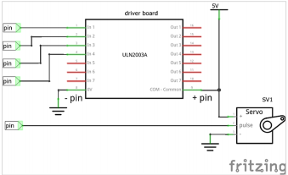

Figure 1 – Circuit Diagram

# Test Plan

The following details a plan for testing the specifications.

|  |  |  |
| --- | --- | --- |
| Test | Procedure | Pass/Fail Criteria |
| 1 |  |  |

# Verification